Verticality Detector (High Precision)

- It is adjusted up and down by using a handwheel and is specifically designed for measuring verticality.
- The installation fixture is equipped with a dial indicator to measure verticality.
- It has a simple structure, is easy to operate and maintain.

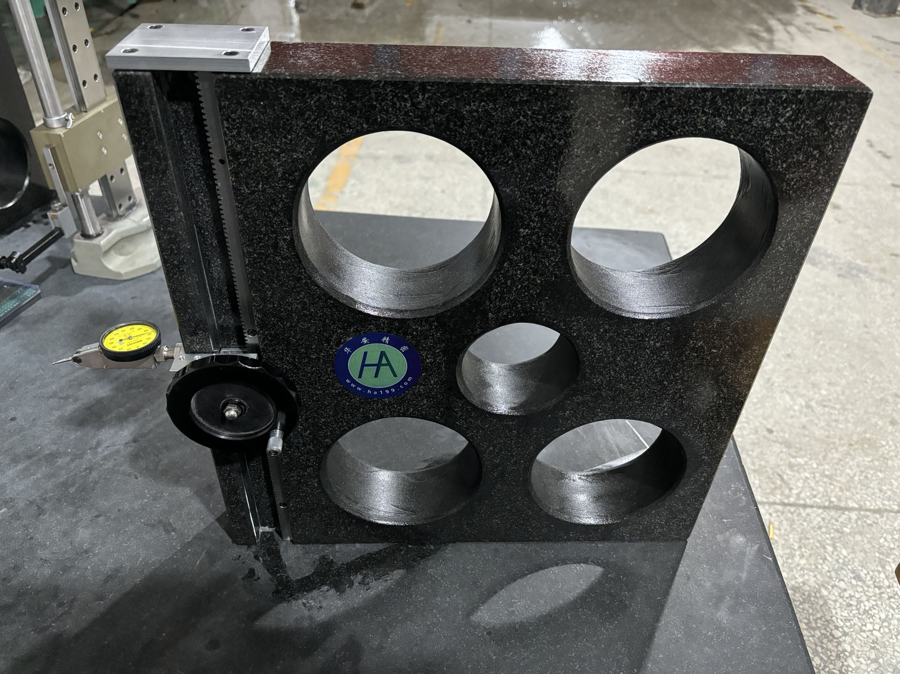
Specifications
Model | Measuring Range（mm） | Graduated Value（mm） | Verticality Measurement（mm） | Height （mm） | Mass（kg）
HA-CZD-45 | 0-350 | 0.001 | ±0.001 | 1000 | 19.8
- Material: High-precision Jinan Black Stone is used (the vertical accuracy of the reference surface can reach 2 micrometers).
- High-precision gauge blocks made of stainless steel are used (with an accuracy of 1 micrometer).
- It can be paired with various measuring tools (such as indicator gauges, dial indicators, scribers, etc.).
- This product is purely mechanical, and its service life is greatly extended.
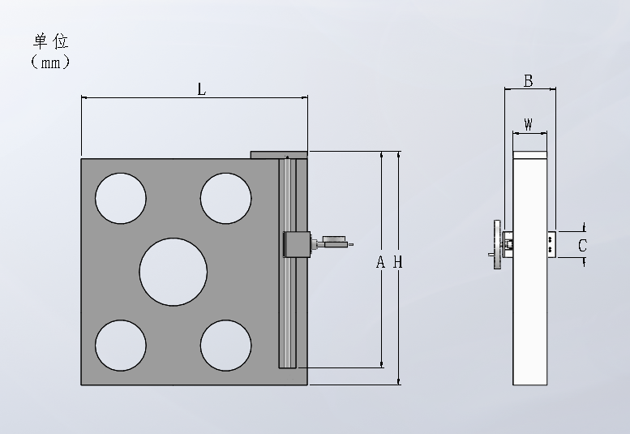

size
model | A | B | C | L | W | H
HA-CZD-45 | 383 | 90 | 45 | 400 | 60 | 413

Directions for use
Marble square foot: Hold the side of the square ruler with your hand and move it slowly and steadily to the right position.
Clamp: Fix the 4 screws on the gauge block, and then install the dial indicator on the clamp, and then fix it.
Handwheel: You can slowly adjust the verticality of the handwheel by slowly adjusting it up and down, placing the product that needs to measure the verticality parallel to the square foot, and then adjusting the lever dial gauge to a suitable position, and slowly and smoothly turning the handwheel to check the beating of the watch to judge the verticality.

