Marble platform bracket

1. When disassembling, the internal screws of the C-shaped steel can be twisted off and removed, which is convenient for storage and does not take up space.

2. The adjustable jack keeps the surface of the platform flat and flat.

- When installing, you only need to fix the internal screws of the C-shaped steel.

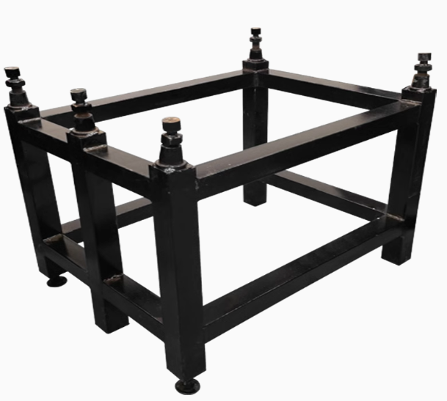

Specifications
Model | Scope of application: leng（mm） | Applicable Width(mm) | Maximum load weight(kg) | Mass (kg)
HA-ZJ-45 | 0-460 | 0-440 | 200 | 15
HA-ZJ-46 | 0-710 | 0-700 | 532 | 25
HA-ZJ-47 | 0-1410 | 0-1120 | 2622 | 35
1. Adjustable jack: let the platform plane be leveled.

2. Detachable specification, the parts can be split into 6 pieces, which is convenient for transportation.

- There are a variety of specifications to meet the use of a variety of platforms and the size adaptation of a variety of platforms, and the choice is rich.

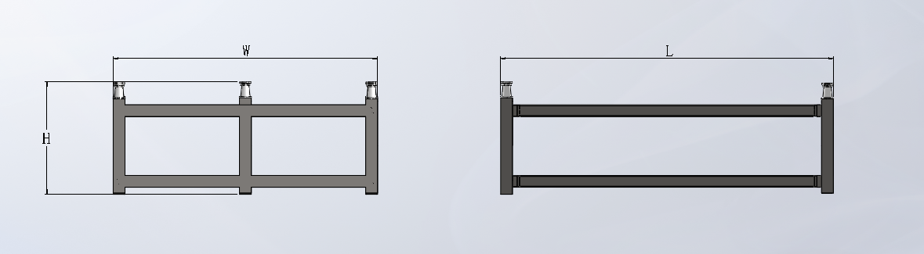
size
Model | L | H | W
HA-ZJ-45 | 460 | 400 | 440
HA-ZJ-46 | 710 | 410 | 700
HA-ZJ-47 | 1410 | 477 | 1120

Directions for use
- C-shaped steel: C-shaped steel is used to fix the bracket, and the inner screws are locked when installing.
- Bracket: There is a foot cup at the bottom for adjustment, which is installed together with C-shaped steel, and a jack is placed on it.
- Jack: Marble can be placed on the jack and can be adjusted in a flat manner.

