Specification： granite triangle（花岗石直角尺 ）
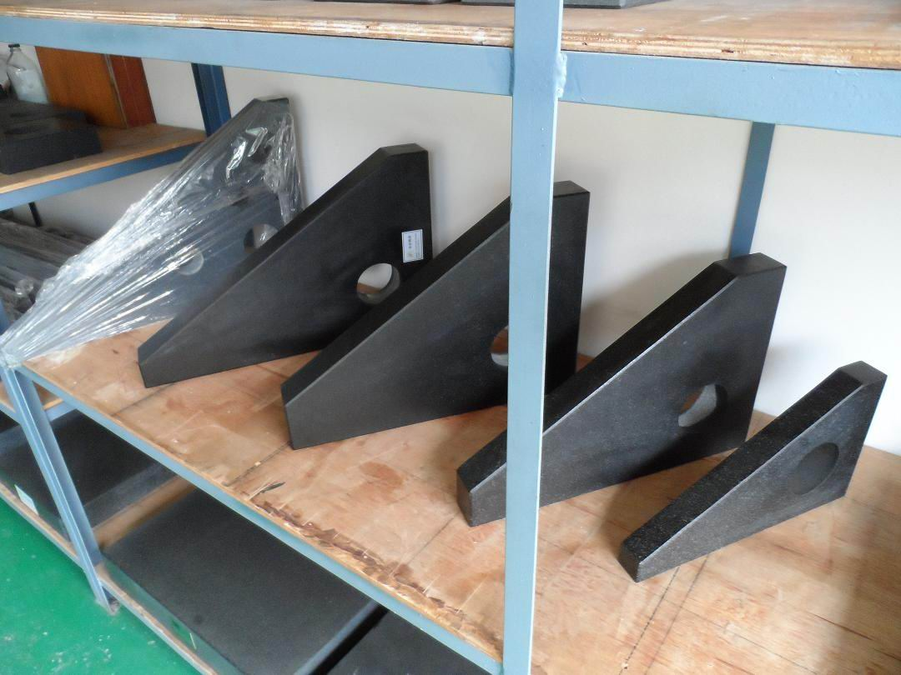
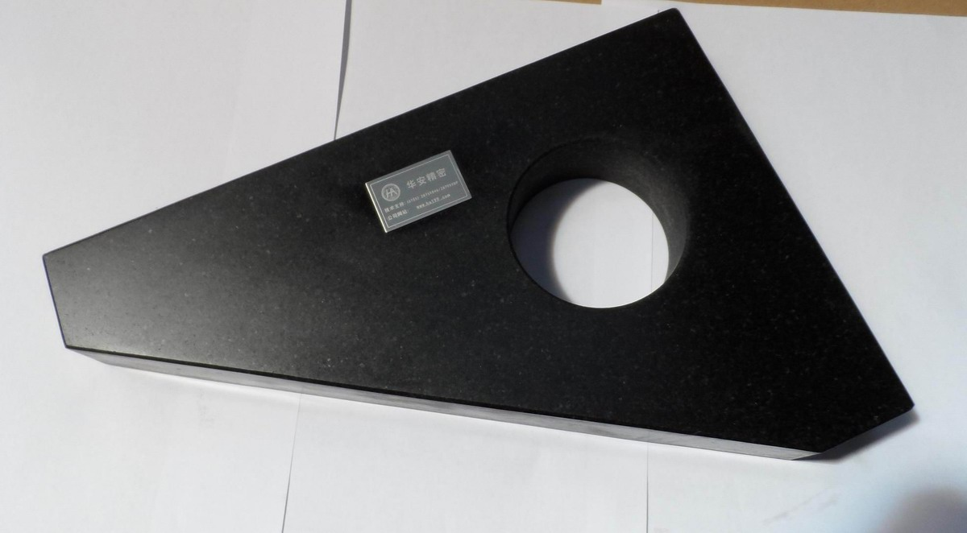
specification model | squareness between measuring surface and datum surface |  | flatness straightness  of measuring surface |  | flatness&straightness  of datum surface |  | overall dimension(mm) | Weight  /unit(kg)
specification model | precision grade(µm) |  |  |  |  |  | overall dimension(mm) | Weight  /unit(kg)
specification model | 00 | 0 | 00 | 0 | 00 | 0 | overall dimension(mm) | Weight  /unit(kg)
SC160*100 | 2 | 4 | 1 | 2 | 1 | 1 | 160×100×25 | 1.23
SC250*160 | 2.5 | 5 | 1 | 2 | 1 | 2 | 250×160×35 | 3.4
SC300*200 | 2.5 | 5 | 1 | 2 | 1 | 2 | 300×200×40 | 5.48
SC400*250 | 3.5 | 7 | 1.2 | 2.5 | 1 | 2 | 400×250×50 | 8.35
SC500*315 | 3.5 | 7 | 1.5 | 3 | 1 | 2 | 500×315×60 | 18.9
SC630*400 | 4.5 | 9 | 1.5 | 3 | 1.2 | 2.5 | 630×400×70 | 29.81
SC1000*630 | 6 | 12 | 2.5 | 5 | 1.5 | 3 | 1000×630×100 | 138.5

备注(notes): 规格specifications (mm);精度等级Precision grade 000级;平面度Grade 000 flatness(μm)00级平面度Grade 00 flatness(μm) 0级;平面度Grade 0 flatness(μm)1级;平面度Grade 1 flatness(μm) ;净重KG

