granite inspection parallelism plate Specifications（规格或型号）:
specification  model | straightness&flatness of working surface |  | parallelism between working surfaces |  | squareness between working surface and side surface |  | overall dimension(mm) | weight/unit(kg)
specification  model | precision grade(µm) |  |  |  |  |  | overall dimension(mm) | weight/unit(kg)
specification  model | 00 | 0 | 00 | 0 | 00 | 0 | overall dimension(mm) | weight/unit(kg)
SP400 | 1.6 | 2.6 | 2.4 | 3.9 | 8 | 13 | 400×60×35 | 3.14
SP630 | 2.1 | 3.5 | 3.2 | 5.3 | 10.5 | 18 | 630×100×50 | 10.74
SP1000 | 3 | 5 | 4.5 | 7.5 | 15 | 25 | 1000×160×50 | 46
SP1600 | 4.4 | 7.4 | 6.6 | 11.1 | 22 | 37 | 1600×200×80 | 82.2
SP2000 | 5.4 | 9 | 8.1 | 13.5 | 27 | 45 | 2000×250×100 | 159.6

Note : no standard products could be made to meet customer's special requirements
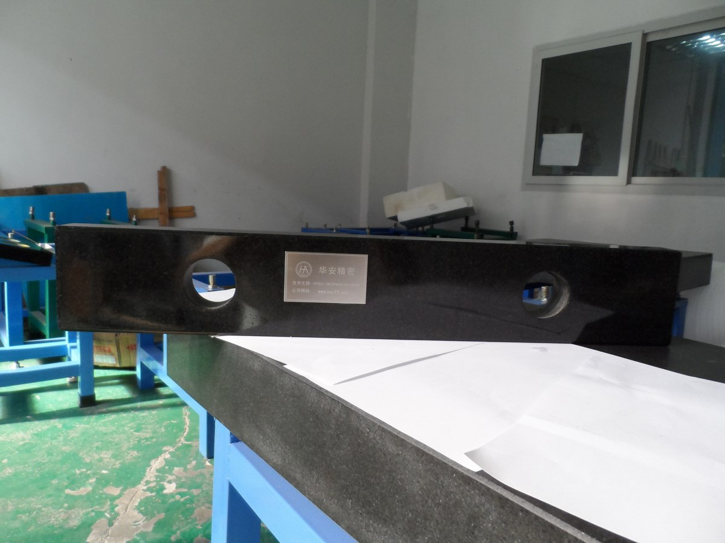
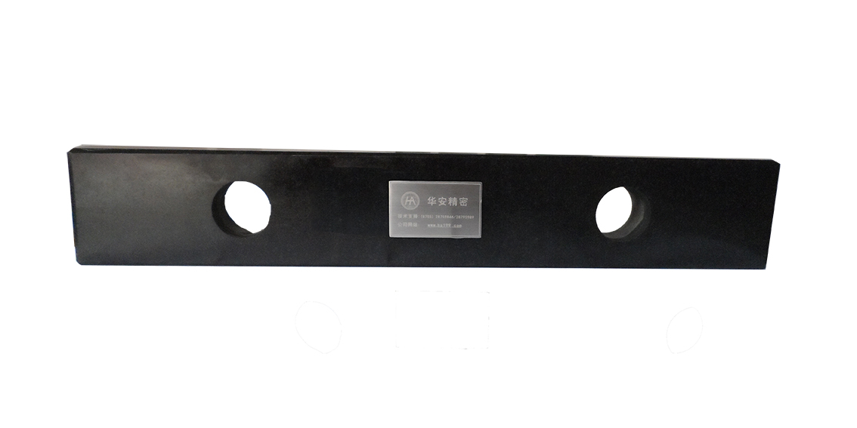

备注(notes): 规格specifications (mm);精度等级Precision grade 00级;平面度Grade 00 flatness(μm)00级平面度Grade 00 flatness(μm) 0级;平面度Grade 0 flatness(μm)1级;平面度Grade 1 flatness(μm) ;净重kg

