Gauge block and equal block
Gauge blocks can be selected of 12 blocks :

Small 12 blocks | Standard measuremets | Marked long(mm),working face | Long(mm) | Wide(mm) | Working face | tolerance | grade 0 | Grade 1 | Grade 2 | Weight(KG)
1 | 10 | 10.000 | 50.000 | 50.000 | 10.000 | 1μm | 0.280 | 0.560 | 1.120 | 0.075
2 | 12 | 12.000 | 50.000 | 50.000 | 12.000 | 1μm | 0.280 | 0.560 | 1.120 | 0.090
3 | 15 | 15.000 | 50.000 | 50.000 | 15.000 | 1μm | 0.280 | 0.560 | 1.120 | 0.113
4 | 20 | 20.000 | 50.000 | 50.000 | 20.000 | 1μm | 0.280 | 0.560 | 1.120 | 0.150
5 | 25 | 40.000 | 50.000 | 50.000 | 40.000 | 1μm | 0.400 | 0.800 | 1.600 | 0.300
6 | 50 | 50.000 | 50.000 | 50.000 | 50.000 | 1μm | 0.400 | 0.800 | 1.600 | 0.375
7 | 75 | 80.000 | 50.000 | 50.000 | 80.000 | 1μm | 0.600 | 1.200 | 2.400 | 0.600
8 | 100 | 100.000 | 60.000 | 60.000 | 100.000 | 1μm | 0.600 | 1.200 | 2.400 | 1.080
9 | 125 | 125.000 | 60.000 | 60.000 | 125.000 | 1μm | 0.800 | 1.600 | 3.200 | 1.350
10 | 150 | 150.000 | 60.000 | 60.000 | 150.000 | 1μm | 1.000 | 2.000 | 4.000 | 1.620
11 | 175 | 175.000 | 60.000 | 60.000 | 175.000 | 1μm | 1.000 | 2.000 | 4.000 | 1.890
12 | 200 | 200.000 | 60.000 | 60.000 | 200.000 | 1μm | 1.000 | 2.000 | 4.000 | 2.160

Equal block is as the following list:
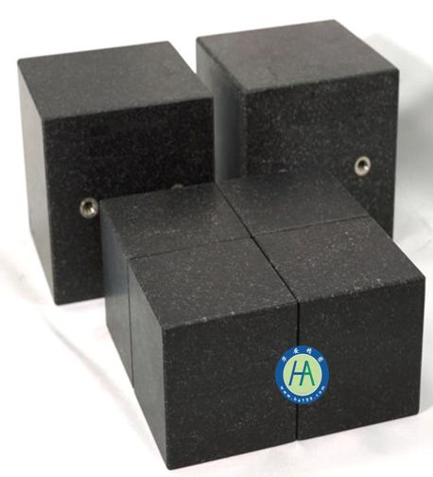

long | wide | height | Grade | Weight(KG) | Group for 4 units | Group (KG)
80 | 80 | 100 | 1μm | 1.92 | 4.00 | 7.68
100 | 100 | 100 | 1μm | 3.00 | 4.00 | 12.00
150 | 150 | 120 | 2μm | 8.10 | 4.00 | 32.40
200 | 200 | 120 | 2μm | 14.40 | 4.00 | 57.60

The function of the gauge and equal blocks :
1,the selected material is JI NAN Qin,a kind of Chinese natural black granite stone, which can keep steady,
And mis-shape is one third of cast iron;
2, Acid and alkali resistant, never rusts, never magnetizes;
3, With convenient carry handles and move on the face of testing stand smoothly.

