Flatness measuring gage

- Able to measure flatness smoothly 3. Adjustable up and down distance of flexible section table

2. Hold the base part by hand to move 4. A variety of meter heads can be replaced

Specifications
Model | Graduated Value（mm） | flatness measurement（mm） | Mass（kg）
HA-PX-3 | 0.001 | ±0.001 | 3.55

1. The base is designed with a stable and easy-to-push shape, which is convenient for pushing and pulling.
2. The length can be adjusted back and forth, which can cope with different measurement environments.
3. Install the back piston type indicator meter, which can adjust the detection point up and down to make it fully contact with the plane.
4. Tips: Can not be in contact with water stains for a long time, you can add some lubricating oil to prolong the life.

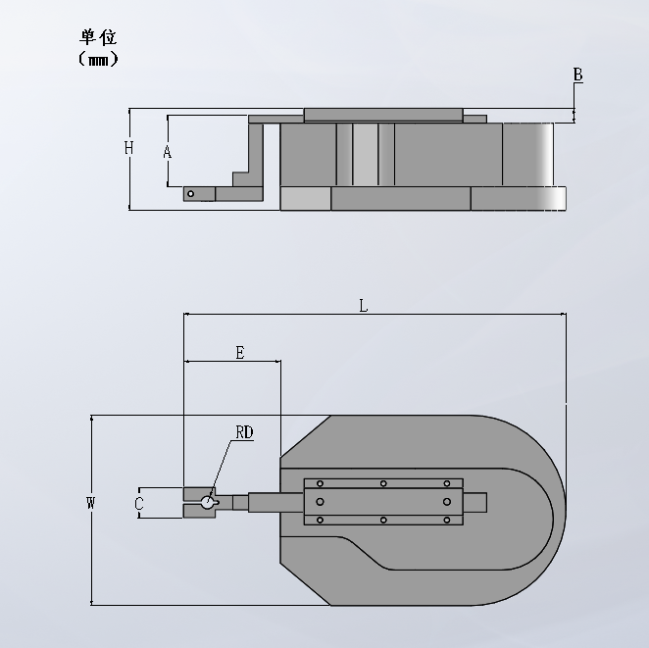

size
Model | A | B | C | D | E | L | W | H
HA-PX-3 | 45 | 9.5 | 19 | 4 | 61 | 241 | 120 | 54.5

Directions for use
- Base: The base is suitable for hand pushing, which can be moved forward, backward, left and right, and the built-in T-shaped slot is matched with the T-row block.
- T-block: The front and rear positions can be adjusted by pushing and pulling back and forth, which is suitable for measurement in different environments.
- Tighten the screws: Loosen the screws when adjusting the T-block, adjust to the appropriate position and then tighten the screws.
- Gauge clamp: Replaceable back-mounted high-precision gauge for more intuitive observation of readings, and can also be replaced with a lever dial indicator (0.001) for measurement.

