Absolutely Digital Vernier Caliper
一、Characteristics is as the following:
- The resolution ratio is 0.01mm,it is easier for user to read；
- Use “Absolutely measuring system”，the zero set of the track can be followed
continuously, the point of starting also can be set to zero at any position；
- Whenever the absolutely digital vernier caliper is used at the beginning, the digital number on the screen can show the right location of the distance from the clipper to the starting point ；
- The moving frame can be adjusted to ZERO/ABS at any location for the comparison。It is very easier to realize conversion of Metric system and Imperial system；
- Material ：4CR13 is used ，the material can keep steady and not easily misshaped, no rustiness and no oxidize; the moving frame can be moved smoothly for a long time ;
- Battery can last 18000 hours, the battery only starts to work when the moving frame is used atomically and powers off after it idles for 5 minutes 。
二、function is as the following ：
- Measurement of external diameter ；（2）measurement of the internal diameter；（3）measurement of depth；（4）measurement of the step。
三、measurements and figure of the digital vernier caliper
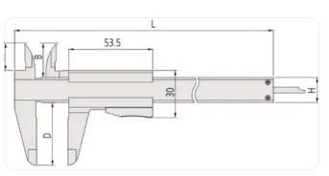
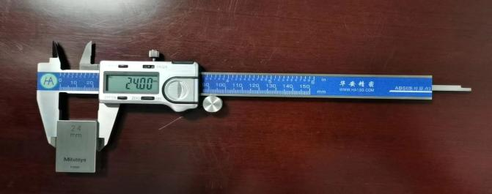

四、scales and measurement of ranges
Resolution and tolerance：Resolution is 0.01mm，tolerance is varied with the range of measurement as the following：
NO | range | resolution | tolerance（+/-） | Weight(g) | A | B | C | D | H | L
2201 | 0-150 | 0.01 | 0.02 | 168 | 16.5 | 21.0 | 14.6 | 40 | 16 | 233
2202 | 0-200 | 0.01 | 0.02 | 198 | 20 | 24.5 | 18.1 | 50 | 16 | 290
2203 | 0-300 | 0.01 | 0.03 | 350 | 22 | 27.5 | 19.8 | 64 | 20 | 404
Warning : never broke or cut the battery and make short-circuit of the battery
；the internal and external paws are very sharp and easy to Injure the people ,children must be guided by the grown-up .

